The distribution of our occupations in our data set is even with most occupations representing between 8 and 19 percent. However, when we look at only people with sleep apnea, we can see that it is predominantly nurses with almost 80 percent of people who have sleep apnea also being nurses. With Insomnia over 70 percent are either teachers or salesperson.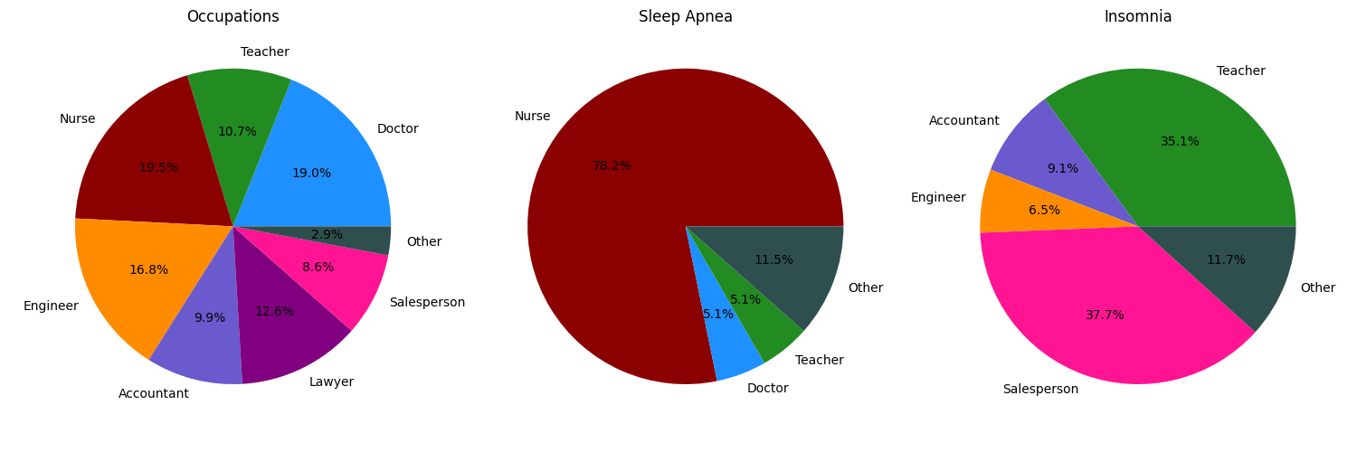

With our data we can also see a strong correlation between the job you have and the level of stress it brings and the sleep duration that you have. We can see from this graph that as stress level increases the amount of sleep you are getting is lowered.

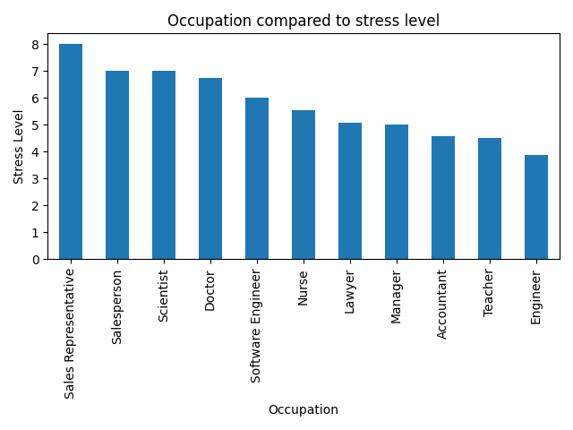

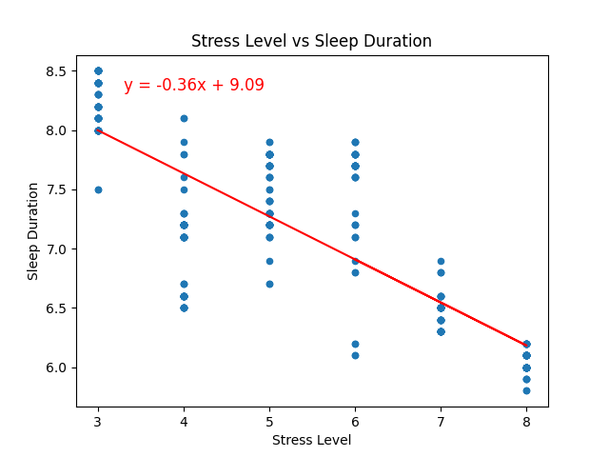This linear regression can show mathematically that stress levels and sleep duration are correlated. There is a strong linear relationship between the two with the higher your stress levels are the lower your sleep duration is. The r squared in this regression is 0.6578 which is quite high and suggests a strong correlation between the two.

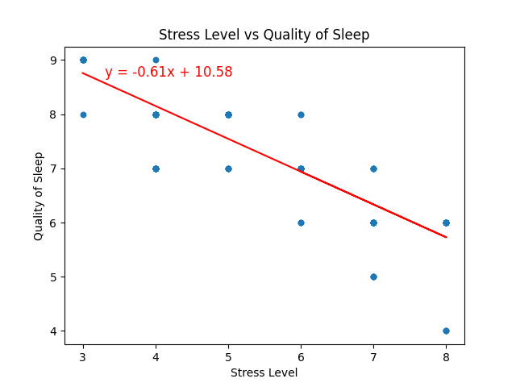This graph also shows that stress level and quality of sleep are strongly related to each other. The r squared on this linear regression is 0.8078 which is even higher, suggesting an even stronger relationship between stress and quality of sleep than stress and duration of sleep.

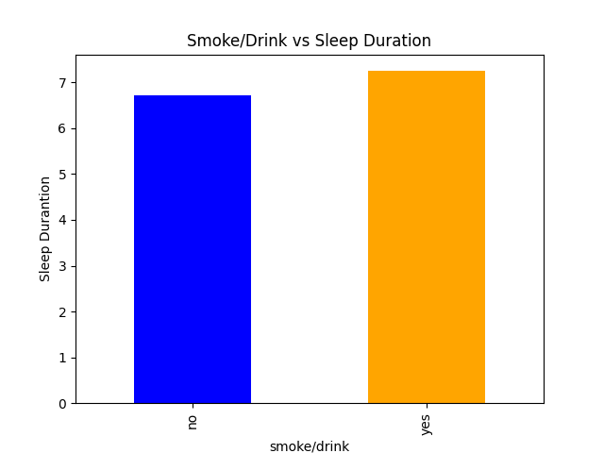We also found some surprising results that showed hardly any difference. For example smoke and or drinking had almost no impact on sleep duration with those who did smoke and or drink sleeping for 7.25 hours a night and those who did not sleeping 6.71 hours a night.

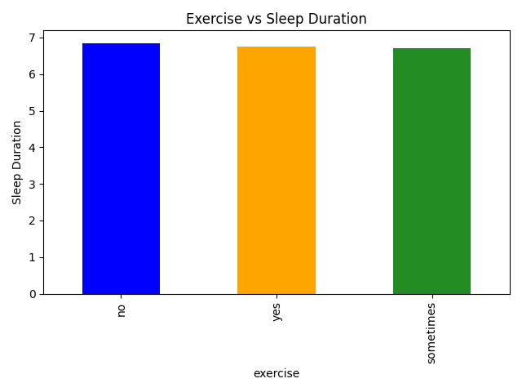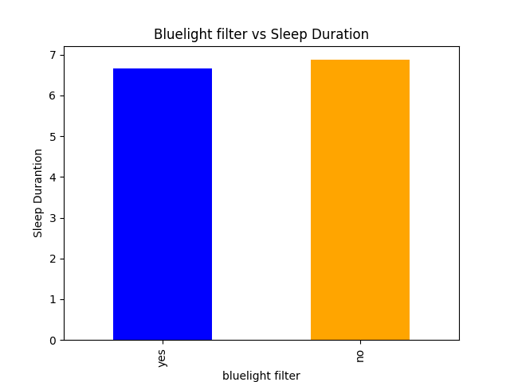Sleep duration was also not affected by blue light filters which was another surprising find as those are some of the most recommended sleep aids. Those who did use them slept on average for 6.66 hours and those who did not use them slept for 6.87 hours.

Exercise also had little impact with those you did exercise sleeping on average 6.75 hours, those who did not sleeping 6.84 hours, and those who sometimes exercised sleeping 6.71 hours.

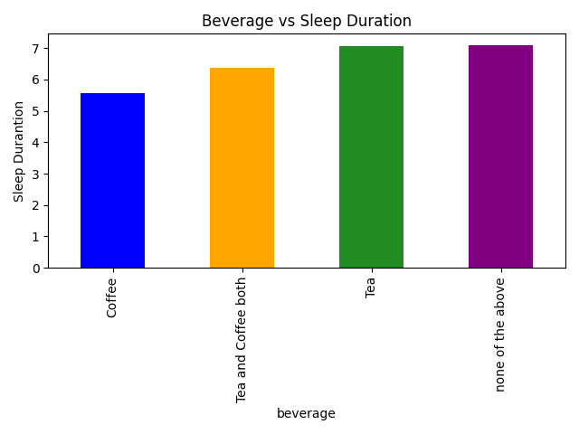Coffee drinking did prove to be significant with coffee drinkers only sleeping on average 5.55 hours a night compared to the average of 6.75 hours across all subjects. Those who drank neither coffee or tea slept more than the average with 7.1 hours. Tea drinkers slept on average 7.07 hours and people who used tea and coffee slept for 6.37 hours on average.